Day #3 – Can anyone do it?

Welcome to Day #3 of 'Govcon for Dummies' training program.

I bet you are thinking to yourself that it can’t be this easy. Of course, Eric you can do it because you have years of experience and 1000’s hours of training.

But Eric, what about someone with no education and no business experience?

Can someone with zero to minimal knowledge about contracts and government do this?

This question is so common that we decided to make an entire lesson discussing this very topic.

Take a look and see for yourself if it is possible.

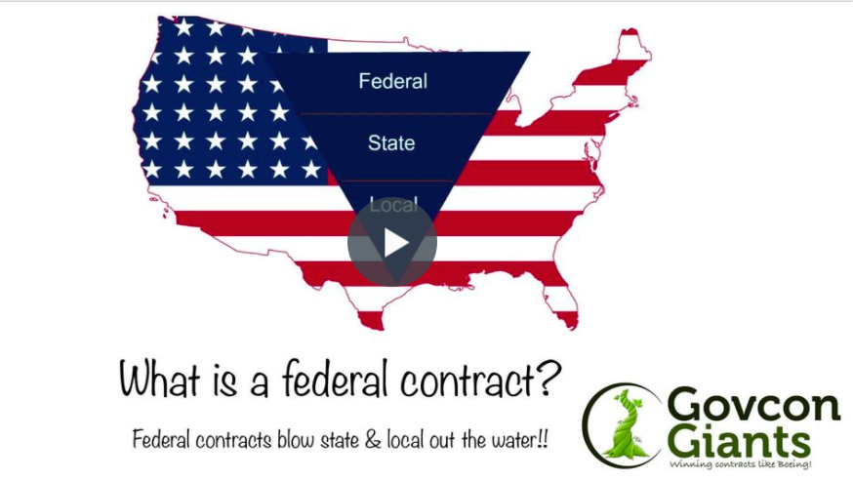

In this video you will learn 5 ways why I like federal contracts and why I believe that anyone can do it.

Learn why you don’t have to have all the money. Find out why being privileged and wealthy may work against you in many of the programs.

Your race doesn’t matter. Your sexual preference is irrelevant.

Start Day #3 Lesson – Click Here

Today’s HW assignment I believe is critical for people who are not as confident in themselves.

Thanks,
Eric Coffie

